SWWU Champs Results

Seeding Round Results:

Male Recurve:

Position | Name | Experience | Uni | Score | Hits | Golds
1st | Alex Rowe | Experienced | Plymouth | 275 | 30 | 9
2nd | Will Ingamells | Experienced | Exeter | 271 | 30 | 10
3rd | Will Black | Experienced | Bristol | 267 | 30 | 10
4th | Jonathan Hui | Experienced | Exeter | 265 | 30 | 4
5th | Joe Tripp | Experienced | Plymouth | 264 | 30 | 9
6th | Daniel Clarke | Experienced | Bath | 262 | 30 | 9
7th | Gavin Tsang | Experienced | Swansea | 262 | 30 | 5
8th | Matt Butler | Experienced | Swansea | 252 | 30 | 7
9th | Jamie Diep | Experienced | Bristol | 241 | 30 | 3
10th | Oliver Squires | Experienced | Cardiff | 238 | 30 | 5
11th | Matt Rapley | Experienced | Bristol | 227 | 30 | 4
12th | Robert Haigh | Experienced | Swansea | 226 | 30 | 2
13th | Peter Darby | Experienced | Bath | 224 | 30 | 1
14th | Matthew Davy | Experienced | Bristol | 222 | 30 | 5
15th | James Jones | Experienced | Cardiff | 219 | 29 | 3
16th | Tom Carver-Hardy | Experienced | Exeter | 210 | 30 | 4
17th | Haralambos Poulasis | Experienced | Plymouth | 203 | 30 | 2
18th | George Overton | Experienced | Bristol | 202 | 30 | 2
19th | George Samways | Experienced | Exeter | 199 | 28 | 4
20th | Matt Ganfield | Experienced | Cardiff | 191 | 29 | 0
21st | Riley Brightwell | Experienced | Swansea | 186 | 30 | 2
22nd | Sam Wainwright | Experienced | Exeter | 173 | 30 | 1
23rd | Henry Barnett | Experienced | Exeter | 169 | 28 | 1
24th | Oscar Johnson | Novice | Plymouth | 169 | 27 | 0
25th | Alex Woolley | Experienced | Exeter | 167 | 23 | 1
26th | Ben Butter | Novice | Exeter | 142 | 27 | 0
27th | Michael Coyne | Experienced | Cardiff | 138 | 27 | 0
28th | Allison Mahmood | Novice | Cardiff | 138 | 25 | 0
29th | Chris Fitch | Novice | Exeter | 123 | 24 | 0
30th | Kieran Guoite | Experienced | Bristol | 119 | 22 | 1
31st | Ricky Cheng | Novice | Swansea | 115 | 22 | 2
32nd | Cameron Crossan | Experienced | Plymouth | 98 | 23 | 0
33rd | Alex Becker | Novice | Bristol | 78 | 14 | 0
34th | Albert Hadi | Novice | Bristol | 74 | 16 | 2
35th | Austin Zhan | Novice | Bristol | 71 | 15 | 0
36th | Nathanail Georgiou | Novice | Bath | 62 | 18 | 0
37th | Robin Nicholson | Novice | Exeter | 54 | 12 | 0
38th | Thomas Homer | Novice | Plymouth | 49 | 9 | 1

Female Recurve:

Position | Name | Experience | Uni | Score | Hits | Golds
1st | Joanne Humphreys | Experienced | Cardiff | 258 | 30 | 4
2nd | Johanna Meyer | Experienced | Bath | 257 | 29 | 8
3rd | Surabhi Desai | Experienced | Exeter | 250 | 30 | 8
4th | Kerry Marks | Experienced | Plymouth | 245 | 30 | 4
5th | Alex Camaly | Experienced | Exeter | 228 | 29 | 3
6th | Amy Roberts | Experienced | Plymouth | 181 | 23 | 1
7th | Lucy Abbott | Experienced | Cardiff | 179 | 29 | 0
8th | Harriet Wood | Novice | Exeter | 176 | 29 | 1
9th | Isobelle Chalmers | Experienced | Swansea | 175 | 29 | 1
10th | Kellie Pettinger | Experienced | Bristol | 174 | 29 | 1
11th | Milla Vehmaa | Novice | Plymouth | 162 | 28 | 2
12th | Megan Naggie | Novice | Swansea | 139 | 26 | 1
13th | Bekah Long | Novice | Swansea | 131 | 23 | 1
14th | Tiffany Mok | Novice | Exeter | 120 | 23 | 2
15th | Majella Johnston | Novice | Plymouth | 110 | 23 | 0
16th | Ruby Thomsett | Novice | Plymouth | 95 | 25 | 0
17th | Lauryn White | Novice | Cardiff | 80 | 18 | 0
18th | Libby Wattam | Novice | Plymouth | 26 | 8 | 0
19th | Paula Ionita | Novice | Bristol | 21 | 7 | 0
Male Compound:

Position | Name | Experience | Uni | Score | Hits | Golds
1st | Jack Pickford | Experienced | Cardiff | 283 | 30 | 14
2nd | Olly Hyland | Experienced | Bath | 278 | 30 | 9
3rd | Matt Walker | Experienced | Swansea | 277 | 30 | 7
4th | Dan Sint Nicolaas | Experienced | Exeter | 258 | 30 | 3
5th | Charlie Lever | Experienced | Exeter | 250 | 30 | 3
6th | Aidan Higginbotham | Experienced | Plymouth | 170 | 23 | 1
7th | Samuel Balson | Novice | Bristol | 119 | 16 | 1

Female Compound:

Position | Name | Experience | Uni | Score | Hits | Golds
1st | Grace Barrett-Rees | Experienced | Swansea | 276 | 30 | 7
2nd | Catherine Hughes | Experienced | Exeter | 271 | 30 | 7
3rd | Becca Eckles | Experienced | Cardiff | 266 | 30 | 3

Male Barebow:

Position | Name | Experience | Uni | Score | Hits | Golds
1st | Lonja Selter | Experienced | Plymouth | 250 | 30 | 4
2nd | James Hayday | Experienced | Swansea | 227 | 30 | 4
3rd | Elliot Shaw | Experienced | Cardiff | 206 | 30 | 1
4th | Andrew Kukielka | Experienced | Bath | 202 | 29 | 3
5th | Ben Hutchinson | Experienced | Bristol | 201 | 30 | 3
6th | Wyn Firth | Experienced | Exeter | 163 | 28 | 2
7th | Hadyn Hayes | Experienced | Swansea | 159 | 28 | 1
8th | Olly Harris | Experienced | Bristol | 139 | 26 | 0
9th | Ben Lindsey | Novice | Plymouth | 135 | 24 | 4
10th | Adam Tankard | Experienced | Swansea | 126 | 27 | 0
11th | Ed Saha | Novice | Swansea | 97 | 19 | 2
12th | Ieauan Klappholz | Novice | Cardiff | 92 | 22 | 0
13th | Szymon Kafel | Novice | Swansea | 14 | 4 | 0

Female Barebow:

Position | Name | Experience | Uni | Score | Hits | Golds
1st | Eloise Hepburn | Experienced | Plymouth | 224 | 30 | 1
2nd | Lauren Manton | Experienced | Bristol | 196 | 29 | 1
3rd | Jasmine Turner | Experienced | Bath | 195 | 30 | 2
4th | Sophie Brain | Experienced | Bristol | 160 | 30 | 3
5th | Maria Adam | Novice | Swansea | 151 | 26 | 1
6th | Katie Stubbs | Experienced | Exeter | 128 | 24 | 0
7th | Harriet Lowbridge | Novice | Cardiff | 127 | 24 | 1
8th | Katherine Pollington | Experienced | Plymouth | 102 | 21 | 0
9th | Kitiana McEwan | Novice | Plymouth | 93 | 20 | 0
10th | Gundra Raissar | Novice | Bristol | 88 | 19 | 0
11th | Sara Aufrère | Novice | Bristol | 76 | 15 | 0
12th | Caitlin Chichester | Novice | Bristol | 71 | 17 | 0
13th | Corinne Jacob-Valentin | Experienced | Bristol | 60 | 16 | 0

Male Longbow:

Position | Name | Experience | Uni | Score | Hits | Golds
1st | Joe Barham | Experienced | Exeter | 84 | 17 | 0
2nd | Kieran Pargeter | Experienced | Bath | 77 | 18 | 0

Female Longbow:

Position | Name | Experience | Uni | Score | Hits | Golds
1st | Emma King | Experienced | Plymouth | 101 | 21 | 2
2nd | Keely Pringle | Experienced | Swansea | 92 | 20 | 0
3rd | Emily Hartley | Experienced | Exeter | 51 | 16 | 0
4th | Stacy Oswald | Novice | Swansea | 13 | 6 | 0

Head to Head Results:

Male Recurve:

Gold | Joe Tripp
Silver | Matt Butler
Bronze | Alex Rowe
4th | Jonathan Hui

Female Recurve:

Gold | Johanna Meyer
Silver | Joanne Humphreys
Bronze | Kerry Marks
4th | Alex Camaly

Male Compound:

Gold | Jack Pickford
Silver | Olly Hyland
Bronze | Charlie Lever
4th | Matt Walker

Female Compound:

Gold | Catherine Hughes
Silver | Grace Barrett-Rees
Bronze | Becca Eckles

Male Barebow:

Gold | Lonja Selter
Silver | James Hayday
Bronze | Andrew Kukielka
4th | Elliot Shaw

Female Barebow:

Gold | Eloise Hepburn
Silver | Jasmine Turner
Bronze | Lauren Manton
4th | Sophie Brain

Male Longbow:

Gold | Kieran Pargeter
Silver | Joe Barham

Female Longbow:

Gold | Keely Pringle
Silver | Emma King
Bronze | Stacy Oswald
4th | Emily Hartley

Team Scores:

Experienced Non-Compound Team Scores
Position | Uni | Teams | Total Score | Total Hits | Total Tens
1st | Plymouth | Alex Rowe  Joe Tripp  Lonja Selter  Kerry Marks | 1034 | 120 | 26
2nd | Exeter | Will Ingamells  Jonathan Hui  Surabhi Desai  Alex Camaly | 1014 | 119 | 25
3rd | Swansea | Gavin Tsang  Matt Butler  James Hayday  Robert Haigh | 967 | 120 | 18
4th | Bristol | Will Black  Jamie Diep  Matt Rapley  Matthew Davy | 957 | 120 | 22
5th | Bath | Daniel Clarke  Johanna Meyer  Peter Darby  Andrew Kukielka | 945 | 118 | 21
6th | Cardiff | Joanne Humphreys  Oliver Squires  James Jones  Elliot Shaw | 921 | 119 | 13

Novice Non-Compound Team Scores
Position | Uni | Teams | Total Score | Total Hits | Total Tens
1st | Plymouth | Oscar Johnson  Milla Vehmaa  Ben Lindsey | 466 | 79 | 6
2nd | Exeter | Harriet Wood  Ben Butter  Chris Fitch | 441 | 80 | 1
3rd | Swansea | Maria Adam  Megan Naggie  Bekah Long | 421 | 75 | 3
4th | Cardiff | Allison Mahmood  Harriet Lowbridge  Ieauan Klappholz | 357 | 71 | 1
5th | Bristol | Gundra Raissar  Alex Becker  Sara Aufrère | 242 | 48 | 0
6th | Bath | Nathanail Georgiou | 62 | 18 | 0

Compound Team Scores
Position | Uni | Teams | Total Score | Total Hits | Total Tens
1st | Swansea | Matt Walker  Grace Barrett-Rees | 553 | 60 | 14
2nd | Cardiff | Jack Pickford  Becca Eckles | 549 | 60 | 17
3rd | Exeter | Catherine Hughes  Dan Sint Nicolaas | 529 | 60 | 10
4th | Bath | Olly Hyland | 278 | 30 | 9
5th | Plymouth | Aidan Higginbotham | 170 | 23 | 1
6th | Bristol | Samuel Balson | 119 | 16 | 1

Thanks for shooting! For the full results arrow by arrow follow this link:
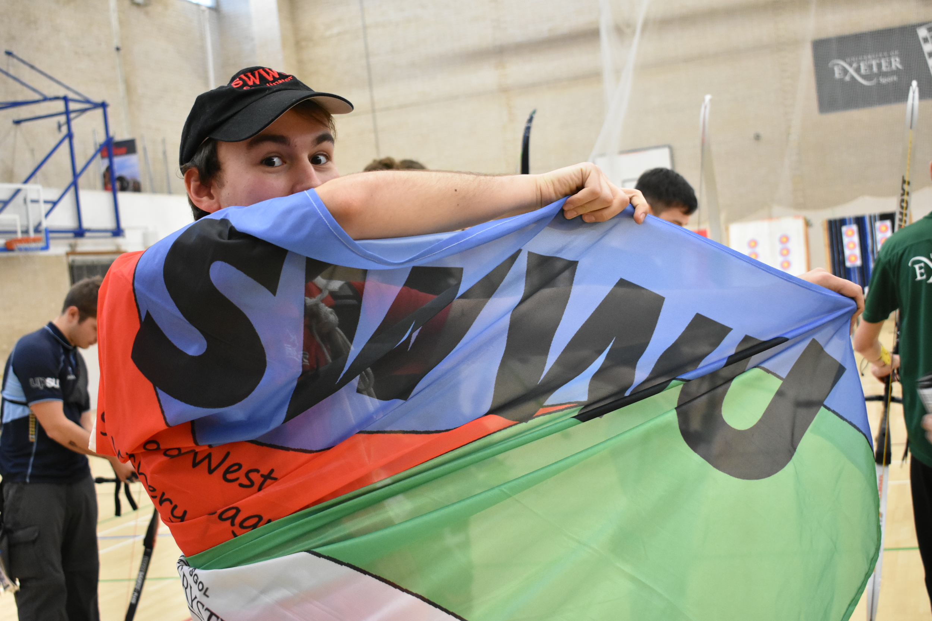
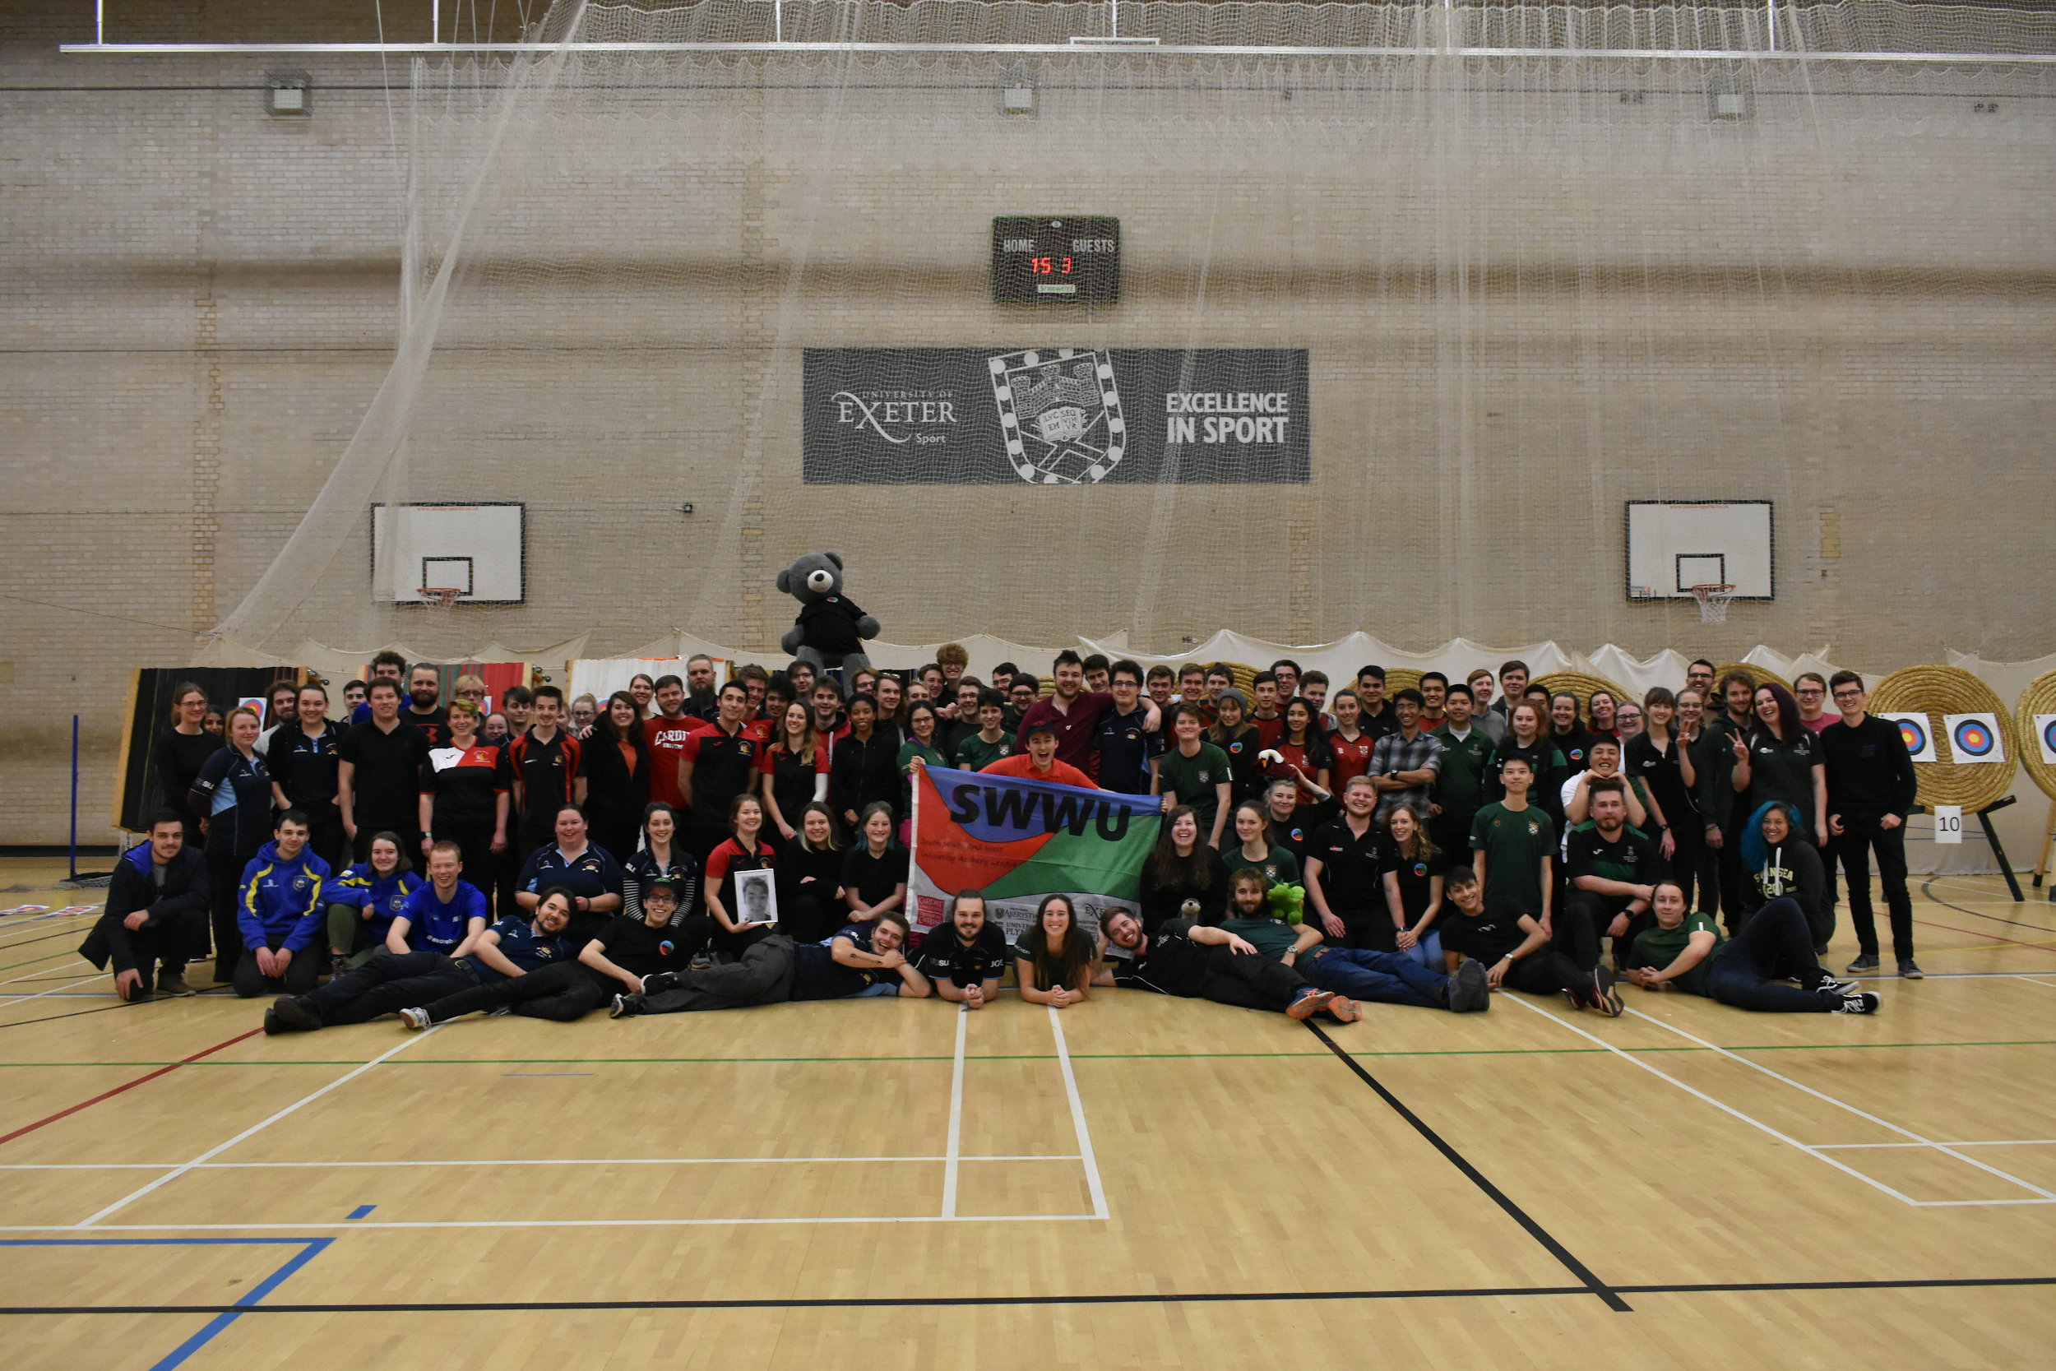
SWWU Champs Scoring

